WORCESTER COUNTY BAR ASSOCIATION
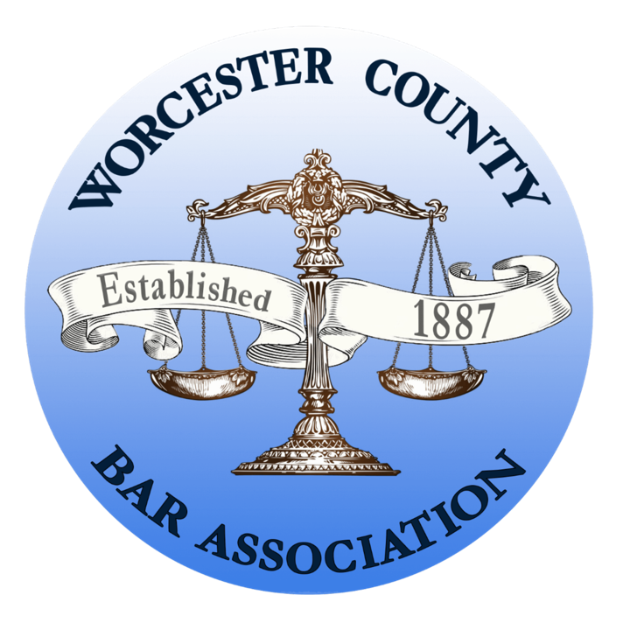

Established 1887

Sponsorship Opportunities
  - Fiscal Year 2027
WCBA offers sponsorship opportunities for events, educational programs, its newsletter, and website.

Annual Meeting
The Annual Meeting is our Premiere Event and is held in early June. There are three sponsorship tiers available, with limited participation capacity for each:

Platinum Sponsor | $5,000
1 sponsorship available
- Sole vendor booth at the event, staffed by sponsor personnel
- Stand-alone logo on the opening PPT slides that appear prior to the event kick-off
- Four event tickets
- Recognition of sponsor’s unique support by our association president
- Sponsor’s branded products* offered to all members in attendance
- Platinum Sponsor listing on all signage and event materials
- Platinum Sponsor listing on the event invitation
- Acknowledgement in all event media and pre- and post-event news releases
- Full-page advertisement in three issues of Legal Lines, our organization’s monthly electronic newsletter sent to all members

Gold Sponsor | $3,000
5 sponsorships available
- Logo on opening PPT slides that run in a loop prior to the event kick-off
- Recognition of our Gold Sponsor’s support by our association president
- Three event tickets
- Sponsor’s branded products* offered to all members in attendance
- Gold Sponsor listing on all signage and event materials
- Acknowledgement in all event media and pre- and post-event news releases
- Full-page advertisement in two issues of Legal Lines, our organization’s monthly electronic newsletter sent to all members

Silver Sponsor | $1,000
10 sponsorships available
- Silver Sponsor listing on all signage and event materials
- Logo on opening PPT slides that run in a loop prior to the event kick-off
- Two event tickets
- Sponsor’s branded products* offered to all members in attendance
- Acknowledgement in all event media and pre- and post-event news releases
- Half-page advertisement in two issues of Legal Lines, our organization’s monthly electronic newsletter sent to all members
*The sponsor must provide the branded products.

Major Events
WCBA major events include the annual Law Day Breakfast, the Public Official Recognition Breakfast, and the New Lawyers Reception. A limited number of sponsorship opportunities are available, outlined below:

Platinum Sponsor | $4,000
1 sponsorship available
- Sole vendor booth at the event, staffed by sponsor staff**
- Stand-alone logo on the opening PPT slides that appear prior to the event kick-off
- Recognition of sponsor’s unique support by our association President
- Four event tickets
- Sponsor’s branded products* offered to all members in attendance
- Platinum Sponsor listing on all signage and event and invitation materials
- Acknowledgement in all event media and pre- and post-event news releases
- Full-page advertisement in three issues of Legal Lines, our organization’s monthly electronic newsletter that is sent to all members

Gold Sponsor | $2,000
5 sponsorships available
- Recognition of our Gold Sponsor’s support by our association President
- Logo on opening PPT slides that run in a loop prior to the event kick-off
- Three event tickets
- Sponsor’s branded products* offered to all members in attendance
- Gold Sponsor listing on all signage and event and invitation materials
- Acknowledgement in all event media and pre- and post-event news releases
- Full-page advertisement in two issues of Legal Lines, our organization’s monthly electronic newsletter that is sent to all members

Silver Sponsor | $1,000
10 sponsorships available
- Silver Sponsor listing on all signage and event and invitation materials
- Logo on opening PPT slides that run in a loop prior to the event kick-off
- Two event tickets
- Sponsor’s branded products* offered to all members in attendance
- Acknowledgement in all event media and pre- and post-event news releases
- Half-page advertisement in two issues of Legal Lines, our organization’s monthly electronic newsletter that is sent to all members
*The sponsor must provide the branded products.
** The New Lawyer Reception does not include a vendor booth.

2026 Holiday Reception

Exclusive Presenting Sponsor | $5,000
1 sponsorship available
- Stand-alone logo on the opening PPT slides that appear prior to the event kick-off
- “WCBA Holiday Reception, presented by…” on invitations, registration page, entrance signage and follow-up communications.
- Vendor booth at the event, staffed by sponsor staff
- Recognition of sponsor’s unique support by our association President
- Eight event tickets
- Sponsor’s branded products* offered to all members in attendance
- Exclusive Presenting Sponsor listing on all signage and event and invitation materials
- Acknowledgement in all event media and pre- and post-event news releases
- Full-page advertisement in four issues of Legal Lines, our organization’s monthly electronic newsletter that is sent to all members

Platinum Sponsor | $4,000
2 sponsorships available
- Vendor booth at the event, staffed by sponsor staff
- Stand-alone logo on the opening PPT slides that appear prior to the event kick-off
- Recognition of sponsor’s unique support by our association President
- Six event tickets
- Sponsor’s branded products* offered to all members in attendance
- Platinum Sponsor listing on all signage and event and invitation materials
- Acknowledgement in all event media and pre- and post-event news releases
- Full-page advertisement in three issues of Legal Lines, our organization’s monthly electronic newsletter that is sent to all members

Gold Sponsor | $2,000
5 sponsorships available
- Recognition of our Gold Sponsor’s support by our association President
- Logo on opening PPT slides that run in a loop prior to the event kick-off
- Four event tickets
- Sponsor’s branded products* offered to all members in attendance
- Gold Sponsor listing on all signage and event and invitation materials
- Acknowledgement in all event media and pre- and post-event news releases
- Full-page advertisement in two issues of Legal Lines, our organization’s monthly electronic newsletter that is sent to all members

Silver Sponsor | $1,000
10 sponsorships available
- Silver Sponsor listing on all signage and event and invitation materials
- Logo on opening PPT slides that run in a loop prior to the event kick-off
- Two event tickets
- Sponsor’s branded products* offered to all members in attendance
- Acknowledgement in all event media and pre- and post-event news releases
- Half-page advertisement in two issues of Legal Lines, our organization’s monthly electronic newsletter
*The sponsor must provide the branded products.
Holiday Reception Additional Opportunities

First Drink Sponsor | $3,500
Provide one sponsored drink ticket per guest, redeemable for a defined selection of alcoholic (wine and beer) or nonalcoholic beverages. The cash bar remains in effect after the ticket is redeemed.
- Stand-alone logo on the opening PPT slides that appear prior to the event kick-off
- Signage at all bars recognizing the First Drink Sponsor
- Recognition of sponsor’s unique support by our association President
- Four event tickets
- Acknowledgement in all event media and pre- and post-event news releases
- Full-page advertisement in two issues of Legal Lines, our organization’s monthly electronic newsletter that is sent to all members

Hospitality Sponsor | $3,500
Sponsor of the passed hors d’oeuvres.
- Stand-alone logo on the opening PPT slides that appear prior to the event kick-off
- Recognition on cocktail napkins and selected highboy signs
- Recognition of sponsor’s unique support by our association President
- Six event tickets
- Hospitality Sponsor listing on all signage and event and invitation materials
- Acknowledgement in all event media and pre- and post-event news releases
- Full-page advertisement in two issues of Legal Lines, our organization’s monthly electronic newsletter that is sent to all members

New Lawyer Welcome Sponsor | $2,500
Underwrite 10 admissions for new lawyers or first-time attendees.**
- Stand-alone logo on the opening PPT slides that appear prior to the event kick-off
- Recognition of sponsor’s unique support by our association President
- Six event tickets (in addition to the 10 tickets for new lawyers)
- New Lawyer Welcome Sponsor listing on all signage and event and invitation materials
- Acknowledgement in all event media and pre- and post-event news releases
- Full-page advertisement in two issues of Legal Lines, our organization’s monthly electronic newsletter that is sent to all members

Annual Golf Tournament
We offer multiple sponsorship opportunities at the WCBA Annual Golf Tournament:

Platinum Sponsor – 1 opportunity at $4,000
- Sole vendor booth at the event, staffed by sponsor personnel*
- 4 tournament tickets
- 1 hole sponsorship
- Stand-alone logo on the PPT slides that appear during the dinner buffet
- Recognition of sponsor’s support by WCBA leadership
- Sponsor’s branded products* offered to all members in attendance
- Sponsor listing on all signage, event materials and invitations
- Full-page advertisement in three issues of Legal Lines, WCBA’s electronic monthly newsletter sent to all members

Gold Sponsor – 5 opportunities at $2,500 each
- 3 tournament tickets
- Stand-alone logo on the PPT slides that appear during the dinner buffet
- Recognition of sponsor’s support by WCBA leadership
- Sponsor’s branded products* offered to all members in attendance
- Sponsor listing on all signage, event materials and invitations
- Full-page advertisement in two issues of Legal Lines, WCBA’s electronic monthly newsletter

Silver Sponsor – 5 opportunities at $1,500 each
- 2 tournament tickets
- Stand-alone logo on the PPT slides that appear during the dinner buffet
- Recognition of sponsor’s support by WCBA leadership
- Sponsor’s branded products* offered to all members in attendance
- Sponsor listing on all signage, event materials and invitations
- Half-page advertisement in two issues of Legal Lines, WCBA’s electronic monthly newsletter

Cart signage – 2 opportunities at $1,000 each
- Logo on all carts used during the tournament
- Recognition in sponsor PPT slides displayed during the dinner

Hole sponsorship – 18 opportunities at $200 per hole
- Sign with sponsor logo at each hole
- Recognition in sponsor PPT slides displayed during the dinner

Dinner Sponsor – 1 opportunity at $1,000
- Sign at the buffet table recognizing the sponsor’s support
- Recognition in sponsor PPT slides displayed during the dinner
- Recognition in all signage, event materials and invitations
- Half-page ad in two editions of Legal Lines, WCBA’s electronic monthly newsletter

Closest to the Pin Sponsor – 2 opportunities at $500 each
- Logo on sign that will appear on the green of the designated hole
- Recognition in sponsor PPT slides displayed during the dinner

Longest Drive Sponsor – 2 opportunities at $500 each
- Logo on sign that will appear on the green of the designated hole
- Recognition in sponsor PPT slides displayed during the dinner

*The sponsor must provide the branded products.

Other Sponsorship Opportunities

First Monday Seminars
On the first Monday of every month from early Fall through May, WCBA hosts educational seminars for its members. All seminars are held via Zoom and some also have an in-person component, being held in the Worcester County Courthouse, during the Court’s lunch hour from 1:00 – 2:00. Approximately 30-50 attorneys attend each seminar which focuses on emerging legal issues, new trends, and practice tips.
The First Monday seminar has one presenting sponsor for the upcoming year (Sep-May), at a level of $2,000 for which they are entitled to the following:
- Acknowledgment in all seminar announcements and with signage at the seminar which will take the following form: The First Monday Education Seminar Series is brought to you by…”
In addition, the sponsor will be recognized by the moderator of each seminar, and is invited to provide pamphlets, brochures, or similar advertisements to be handed out at in-person seminars.

Newsletter
WCBA offers sponsorship of its monthly electronic newsletter for $600 per edition or $6,000 for a year (11 issues) for which the sponsor is entitled to the following:
- Inclusion of an advertisement in the cover email
- Full-page ad in the full newsletter
WCBA offers 1/8 page, ¼ page, ½ page and full-page advertising. Click here for rates.

Website
WCBA offers banner advertising on the Home Page of its website:
- Cost: $2,000 for twelve months (September – August)
- Sponsor logo posted on the WCBA homepage with a hyperlink to the sponsor’s website

Contact Us
To secure a sponsorship opportunity or for additional information, please contact Stephen Altobelli at 508.752.1311 or altobelli@worcestercountybar.org. Payments can be made by calling the office at 508.752.1311 via credit card. Checks should be paid to the order of the Worcester County Bar Association. Our mailing address is 370 Main Street, Suite 925, Worcester, MA 01608.
Organization logos and advertising art should be in either a PDF or JPEG format.

